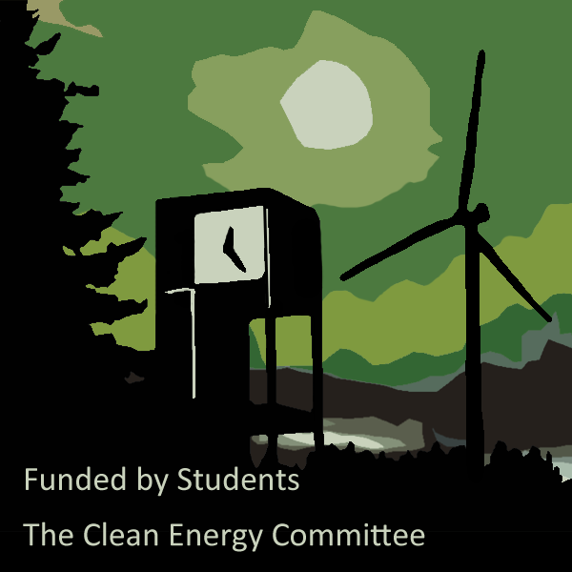

The Clean Energy Fund Grants

CAB 3rd Floor, Olympia, WA 98506

The Clean Energy Fund Grants

CAB 3rd Floor, Olympia, WA 98506

Stage 1 – Planning and Preapproval

* Does your proposal fall into one or more of the three areas eligible for funding; Renewable Energy, Resource Conservation or Sustainability strategies?
* Does your proposal align with the mission of the Clean Energy Committee and Evergreen’s larger commitments to carbon neutrality and zero waste by 2020?
* Have you found a faculty or staff sponsor to support your project? Have they drafted an e-mail of support?
* Have you identified and received the necessary preapprovals and support from the campus areas that will be affected by your proposal?
* Is the project description clear and concise?
* Will your proposal be able to achieve timeline milestones within the allotted time?
* Does your project proposal demonstrate, continuity and lifecycle consideration, and cost effective use of student funds?

Stage 2 – Submission

* Have you included **all** required information in your application and completed it to the best of your ability?
  + Personal Information
  + Reference Information
  + Description, Timeline, Campus Approvals, Sustainability, Continuity, Metrics, Outreach and Education, and a Detailed Budget

Stage 3 – Post Award

* Have you picked up your award letter and received a unique ORG number from Student Activities?
* Have you contacted the CEC to report on the progress of your proposal?
* Are you gathering your proposed metrics and documentation?
* Have you prepared a poster or presentation for the Clean Energy Fair, Synergy and/or Science Carnival?

Stage 1 – Planning and Preapproval

* Does your proposal fall into one or more of the three areas eligible for funding; Renewable Energy, Resource Conservation or Sustainability strategies?
* Does your proposal align with the mission of the Clean Energy Committee and Evergreen’s larger commitments to carbon neutrality and zero waste by 2020?
* Have you found a faculty or staff sponsor to support your project? Have they drafted an e-mail of support?
* Have you identified and received the necessary preapprovals and support from the campus areas that will be affected by your proposal?
* Is the project description clear and concise?
* Will your proposal be able to achieve timeline milestones within the allotted time?
* Does your project proposal demonstrate continuity and lifecycle consideration, and cost effective use of student funds?

Stage 2 – Submission

* Have you included **all** required information in your application and completed it to the best of your ability?
  + Personal Information and Reference Information
  + Description, Timeline, Campus Approvals, Sustainability, Continuity, Metrics, Outreach and Education, and a Detailed Budget
  + Have you visited the CEC office hours for pre-approval and clarifications?

Stage 3 – Post Award

* Have you picked up your award letter and received a unique ORG number from Student Activities?
* Have you contacted the CEC to report on the progress of your proposal?
* Are you gathering your proposed metrics and documentation?
* Have you prepared a poster or presentation for the Clean Energy Fair, Synergy and/or Science Carnival?

Applicant Checklist

Applicant Checklist